ML hw8 report

1. VAE is the artificial neural network architecture introduced by Diederik P. Kingma and Max Welling, belonging to the families of probabilistic graphical models and variational Bayesian methods. Variational autoencoders allows us to re-write statistical inference problems as statistical optimization problems. They are meant to map the input variable to a multivariate latent distribution.

*Advantage:* capable of learning smooth latent state representations of the input data.

*Problem:* VAE models tend to produce unrealistic, blurry samples.

Model 1:

model architecture

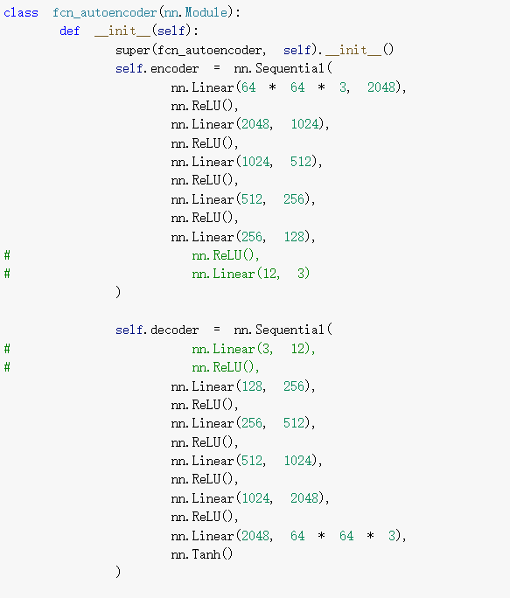 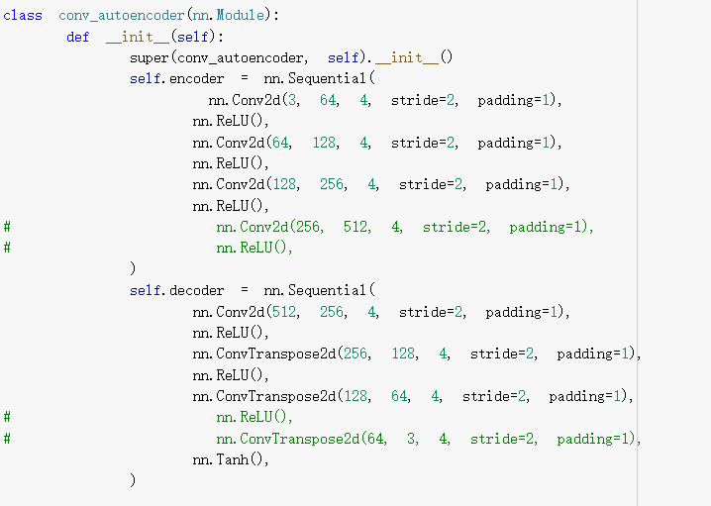

original image

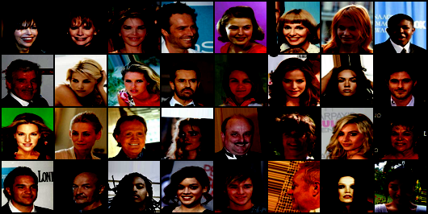

reconstructed images

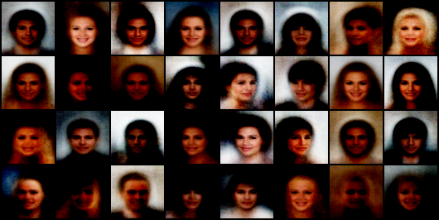

Model 2:

model architecture

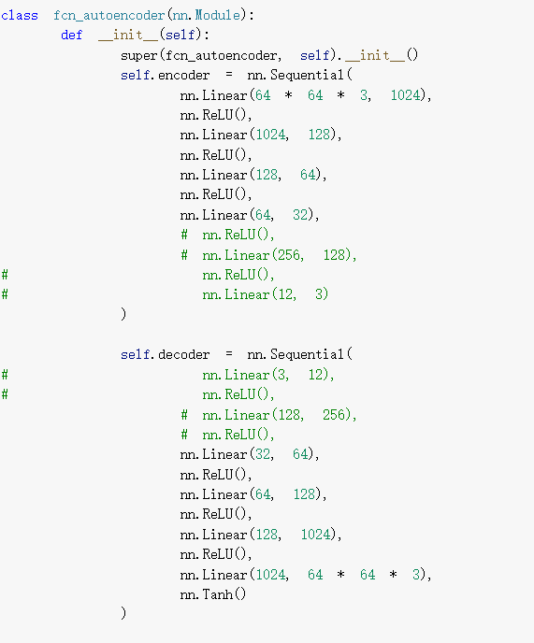 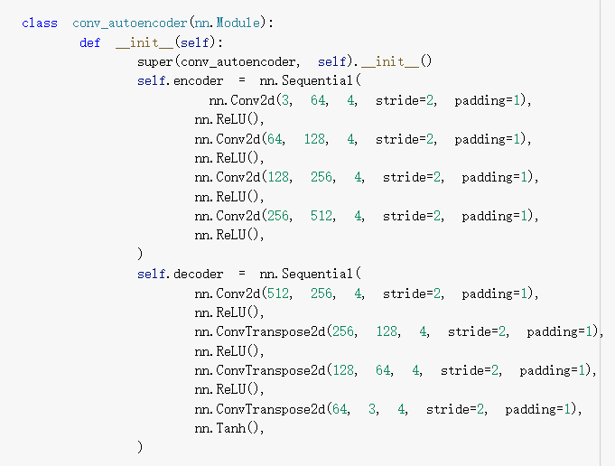

reconstructed images

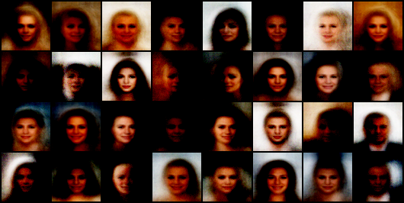

reconstructed images

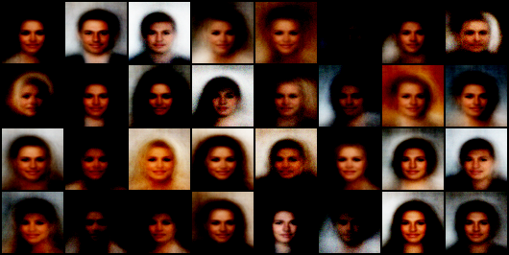

The reconstruct images are more clear as the size of the model become larger.

Model 3:

model architecture

